Fall 2023 Joint Colloquium
Materials Department & Materials Research Laboratory

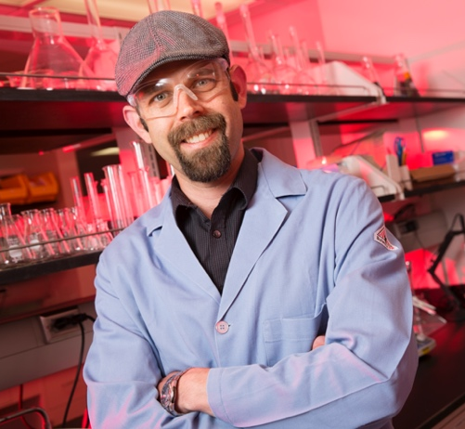
Stephen Morin, PhD

Department of Chemistry
The University of Nebraska - Lincoln
Lincoln, Nebraska

Friday, October 13, 2023
11:00 am | ESB 1001

Building Soft, Stimuli-Responsive Microstructures using Stretchable Chemical Templates

We are investigating new synthetic strategies for the fabrication and operation of adaptive, hybrid
structures comprised of combinations of soft materials with functional (chemical, optical, mechanical,
etc.) properties. Central to these efforts are elastomeric surfaces with heterogeneous chemical and
physical properties that can be reversibly reconfigured using simple, macro-scale processes such as
mechanical deformations. In this talk I will focus on our recent work in the assembly and
micromanipulation of hydrogel prepolymer droplets using stretchable chemical templates.
Hydrogels are functional polymeric materials with stimuli-responsive properties applicable to a wide
range of applications including soft electronics and robotics, three-dimensional cell culture, tissue
engineering, and adaptive optics. Accordingly, the diversity and reported use cases of these materials
has grown tremendously over the past decades, however, the microfabrication of multi-material,
hydrogel-based devices remains a challenge. I will describe a simple microfabrication strategy that
enables the facile production of fixed arrays of stimuli-responsive hydrogel microstructures with
dynamic microactation functionality. Our approach uses rationally designed soft, stretchable chemical
templates to (i) drive the surface assembly of prepolymer droplets into ordered arrays and (ii) provide
surface chemical moieties to photograft materials (i.e., hydrogels) directly to the support. By executing
these critical operations using a single template, we realized a seamless fabrication scheme applicable to
the production of a diversity (in terms of materials and geometries) of functional microgel-based
structures. To demonstrate the utility of our approach and the stability of fixed microgels in liquid phase
applications, I will present prototypical microgel-based devices with stimuli-responsive (e.g.,
solvothermal and chemical) optofluidic and microactuation functionality. We envision many
technologies, for example, liquid phase soft microactuators, stimuli-responsive 3D cell culture platforms,
and micro/optofluidic chips, will directly benefit from the use of stretchable chemical templates in the
fabrication of microgel-based, multi-material structures.

Bio
Stephen A. Morin is an Associate Professor, with tenure, in the Department of Chemistry at The
University of Nebraska – Lincoln. His research interest include: materials chemistry, nano-/microscale
assembly, nanomaterials synthesis and characterization, adaptive materials, soft robotics, hybrid
materials systems, and bottom-up fabrication. Stephen completed his B.S in Chemistry at The University
of Texas at Austin in 2004. He received his Ph.D. in Chemistry in 2011 from the University of Wisconsin -
Madison. From 2011 until 2013, Stephen was a postdoctoral fellow in the lab of Professor George M.
Whitesides in the Department of Chemistry and Chemical Biology at Harvard University. Stephen joined
the faculty in the Department of Chemistry at UNL in Fall of 2013 and received tenure in Fall of 2019. He
was awarded a 3M Non-tenured Faculty Award in 2015 and an NSF CAREER Award in 2016. He has
published over 50 peer reviewed publications with over 4,000 citations.

http://chemweb.unl.edu/morin/

Hosted by Chris Bates

